Project Design Phase-I Solution Architecture
Quotes Recommendation Chatbot using Rasa NLU

Date | 07 March 2026
Team ID | SmartBridge-EL-2026
Project Name | Quotes Recommendation Chatbot using Rasa NLU
Maximum Marks | As per evaluation criteria

SmartBridge Experiential Learning Program
Team Members: Vansh Malhotra | Varun Gaikwad | Vedika Tandulwadkar | Vidisha Jain
Solution Architecture:
Solution architecture is a complex process – with many sub-processes – that bridges the gap between business problems and technology solutions. Its goals are to:

- Find the best tech solution to solve the existing business problem of delivering quotes via a conversational chatbot.
- Describe the structure, characteristics, behaviour, and other aspects of the software to project stakeholders.
- Define features, development phases, and solution requirements.
- Provide specifications according to which the solution is defined, managed, and delivered.

Solution Architecture Diagram:
The diagram below shows all components of the Quotes Recommendation Chatbot and how they connect and communicate at runtime:

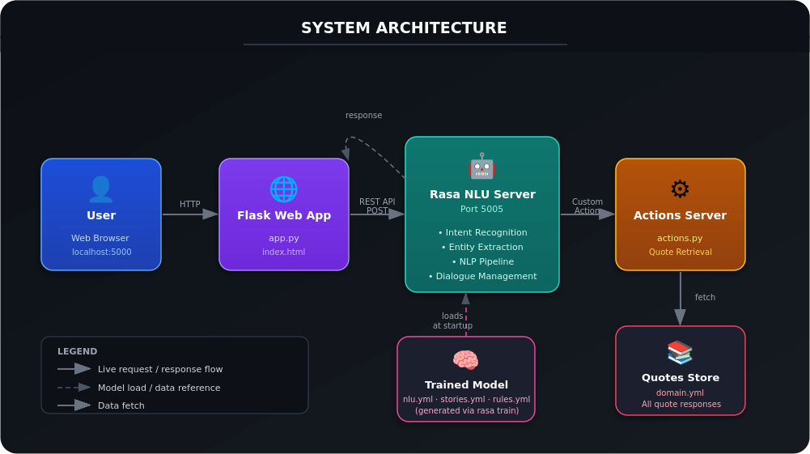
Figure 1: System Architecture — Quotes Recommendation Chatbot using Rasa NLU
Key components of the architecture:
- User (Browser) — the end user who opens the chat UI at localhost:5000 and types messages.
- Flask Web App (port 5000) — serves index.html and forwards messages to the Rasa REST API.
- Rasa NLU Server (port 5005) — classifies intent from user text using the trained ML model.
- Actions Server (actions.py) — triggered by Rasa; selects and returns the appropriate quote.
- Quotes Store (domain.yml) — all predefined quotes stored per category, loaded in memory.
- Trained Model — generated from nlu.yml and stories.yml via 'rasa train'; loaded at startup.

Project Flow Diagram
The diagram below shows the step-by-step flow of a single user interaction from opening the browser to receiving a quote response:

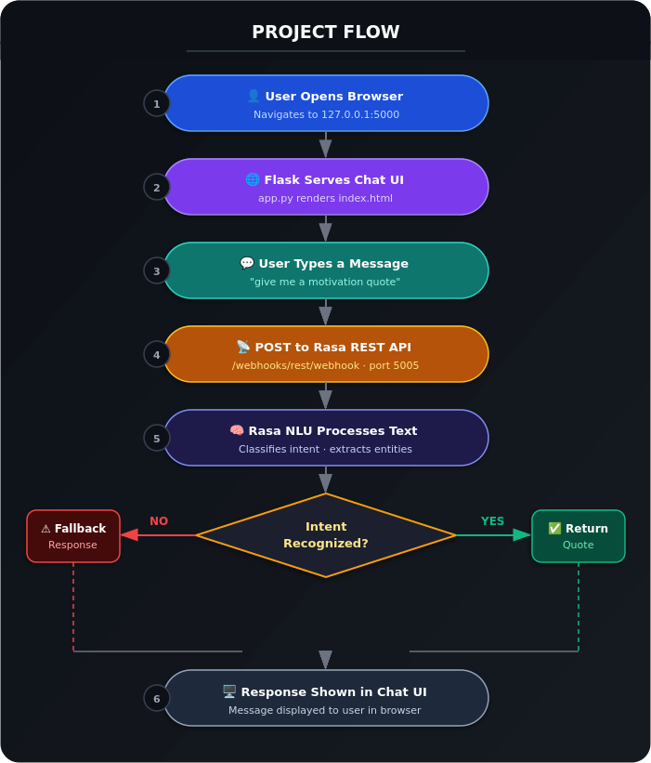
Figure 2: Project Flow — End-to-end user interaction

Table 1: Components & Technologies
S.No | Component | Description | Technology
1 | User Interface | Chat UI — how the user interacts with the chatbot | HTML5, CSS3, JavaScript, Jinja2 (Flask templates)
2 | Web Application | Serves the chat UI and forwards messages to the Rasa REST API | Python 3.9, Flask 2.x, Requests library
3 | NLU Engine | Classifies user intent from natural language text input | Rasa NLU 3.6.x, spaCy, TensorFlow
4 | Dialogue Management | Controls conversation flow using rules, stories and policies | Rasa Core — rules.yml, stories.yml
5 | Custom Actions | Python functions that execute when an intent is triggered — returns quote | Python 3.9, actions.py, Rasa SDK
6 | Quotes Data Store | All predefined quotes stored per category, loaded at runtime | YAML — domain.yml (in-memory)
7 | Trained NLP Model | ML model trained on labelled intent data for text classification | Rasa NLU pipeline, spaCy en_core_web_md
8 | REST API | Communication interface between Flask web app and Rasa server | Rasa REST Webhook — /webhooks/rest/webhook
9 | Infrastructure | All components run locally — no cloud deployment for MVP | Local server, Windows/Linux, Python venv, port 5000/5005

Table 2: Application Characteristics
S.No | Characteristic | Description | Technology
1 | Open-Source Frameworks | All technologies are fully open-source with no licensing costs | Rasa (Apache 2.0), Flask (BSD), Python (PSF), spaCy (MIT)
2 | Security | No user data stored. CORS enabled for local dev. No authentication required for MVP | CORS (*), local network only, no persistent storage
3 | Scalable Architecture | 3-tier architecture separates UI, logic, and data. Rasa and Actions run as independent services — each can be scaled independently | Microservice-style: Flask + Rasa server + Actions server
4 | Availability | Application is available for the full session. Cloud deployment would enable 24/7 availability | Local: manual start; Future: Docker + AWS/Azure
5 | Performance | Response time < 2s locally. Rasa processes NLU in-memory using pre-loaded trained model | In-memory model inference, Flask development server

Data / Request Flow
Step | Process | Data Transferred
1 | User sends message via browser | Text: 'give me a motivation quote'
2 | Flask forwards to Rasa REST API | HTTP POST — JSON: {sender: user, message: text}
3 | Rasa NLU classifies intent | Intent label: motivational_quote (with confidence score)
4 | Rasa triggers custom action | Action: action_motivational_quote
5 | actions.py fetches quote | Quote string selected from domain.yml responses
6 | Response returned to Flask | JSON: {text: 'Your only limit is your mind.'}
7 | Flask renders reply in browser | Quote displayed as bot message chat bubble in the UI

Deployment Architecture
Parameter | Details
Environment | Local development machine — Windows / Linux
Language Runtime | Python 3.9 virtual environment (venv)
Server 1 (Terminal 1) | Rasa server: rasa run --enable-api --cors "*" → port 5005
Server 2 (Terminal 2) | Flask app: python app.py → port 5000
User Access | Browser at http://127.0.0.1:5000
Local Dependencies | Python 3.9, Rasa 3.6.x, Flask, spaCy, TensorFlow — installed via requirements.txt
Future Deployment | Docker containerisation + Cloud deployment on AWS / Azure

References
GitHub Repository: https://github.com/VarunGaikwad-tech/quotes-recommendation-chatbot-rasa
Rasa Documentation: https://rasa.com/docs/rasa/
Flask Documentation: https://flask.palletsprojects.com/
Architecture Reference: https://c4model.com/

